Cyclsitic’s bike-share analysis Report

**Capstone Project -2**

**DMT2T3– Business Analytics and Digital Marketing**

**Done By Nimalan K**

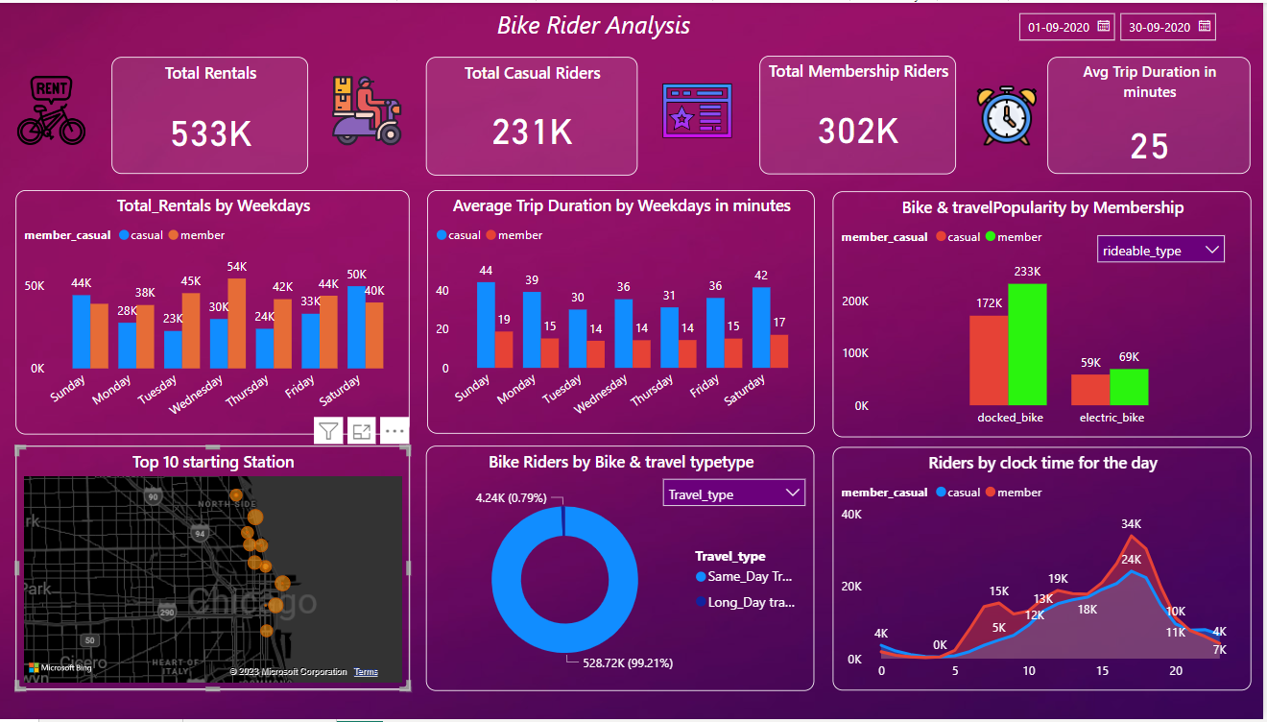

**Problem Statement**

You are a junior data analyst working in the marketing analyst team at Cyclitic, a bike-share company in Chicago. The director of marketing believes the company’s future success depends on maximizing the number of annual memberships. Therefore, your team wants to understand how casual riders and annual members use Cyclitic bikes differently. From these insights, your team will design a new marketing strategy to convert casual riders into annual members. But first, Cyclitic executives must approve your recommendations, so they must be backed up with compelling data insights and professional data visualizations.

**Objective of the Project**

There are 2 types of cyclistic’s those who purchase casual tickets and those purchase annual memberships. The Marketing team believes number of annual memberships will be key future growth. Rather than creating a new marketing campaign for the new customers, there is a very good chance of converting the casual members.

To find the most effective marketing strategy of converting the Cyclistic’s casual riders to annual Membership Riders.

To find how do the Annual Members and casuals riders use the Cyclistic’s bike differently.

**Summary of the Insights & Findings**

**Primary KPI (Key Performance Indicators)**

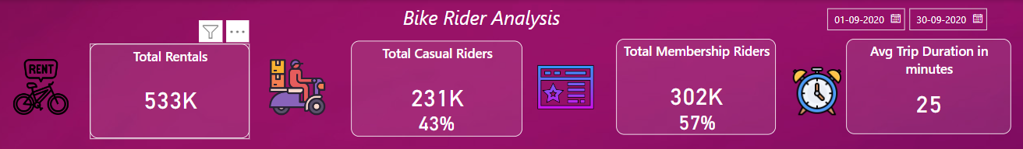

Here I have used the card visuals to find total rentals happens in the month of September which is 533K members opted for a ride, from that 231k are casual riders and 302 are annual members which clearly shows that company is in good position as the annual membership is very high, need to convert 231K at least 50% of casual riders to annual members. Average trip timing for both casual and annual members is 25 minutes from Start station to End Station

**Rides per weekdays**

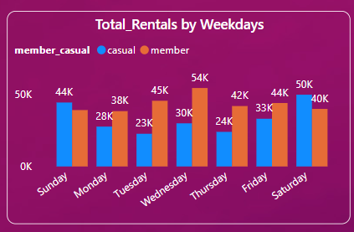

From the chart it is clearly observed that annual members are riding the bike in week days from Monday to Friday which greater compared to casual members. Peak day is Thursday which is 54K rentals. Casual members are riding the bike in weekends from Saturday & Sunday which is greater compared to annual members. Peak day is Saturday which is 50K. From this chart we can find that Casual members are riding for relaxation purpose to burst out their stress from their working days. Annual members as they paid for the whole year they need to utilize the ride that they might use these for their routine rides to their office, or other occasions.

**Average trips Duration**

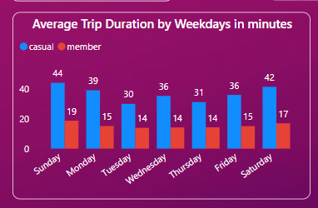

From the chart it is clearly observed that casual members are riding the bike for longer time compared to annual members. On Avg Casual members are riding for 36 minutes from start to end. On Avg Annual members are riding for 16 minutes from start to end. During weekend the ride time duration is long when compared to weekdays for both Casual and Annual members. From this chart we can find that Casual members are riding for relaxation purpose to burst out their stress from their working days. Annual members as they paid for the whole year they need to utilize the ride that they might use these for their routine rides to their office, or other occasions.

**Bike Popularity**

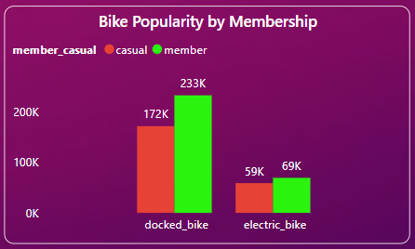

From the chart it is observed that in docked bike 233K rents registered on annual Members and 172K registered on casual Members. Electric bike is very low almost 60% compared to Docked bike for both casual & annual between them only 10K rental is the difference. This might be due to higher subscriptions charges for Electric bike or Electric bike is an upcoming technology still in R&D process like they are suffering from battery short circuit leading to fire accident. Docked bike are more convenient to ride for good exercise compared to electric. Most members are using the Electric bike for transportation purpose.

**Top 10 Starting Station**

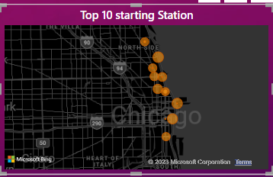

From the chart it is observed the Top 10 most riders start from Chicago Lake front Trail Bridge holds the first position and 10th Position acquired by Wellington Avenue. 2nd and 3rd Position acquired by E lake Shor Dr and E Grand Avenue

**Bike usage & Travel Type**

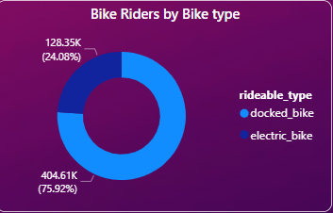 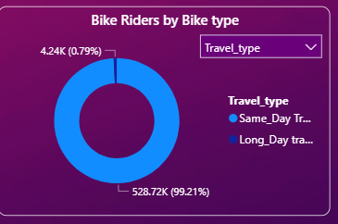

From the chart it is observed as like previous comparisons between casual & Annual members, docked bikes are used to for both personal transport & Relaxation purpose.

Same day travel which are both Casual & Annual preferring more than long day travel which more than 1 day around 4350 members are using long rental

**Riders by clock time for the day**

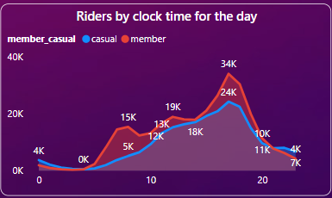

From the chart it is observed Annual members are utilizing the rentals more than casual members. From Midnight 12:00 AM to 4:00 AM there no ride registered as it is a sleeping time, from morning 5:00 AM the riders numbers are increasing from both Annual & Casual Members for the fitness purpose and it is gradually rising till 9:00 AM. There is a slight decline between 9:00 AM to 10:00 AM as most of the members are getting ready for the work. From 10:00 AM it is again gradually increasing they are using the bike for general transportation to their office or personal work. Peak time is 5:00 PM as the office ending time both casual and Annual members using the rentals for fitness purpose & general transportation. And the interesting part is till 11:00 PM the both the members are riding the bikes, they might be practicing for Tour De France competition.

**Average Distance travelled from Start Station to End Station**

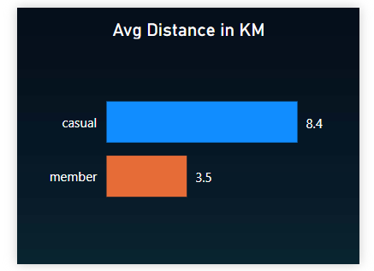

Casual Members travelling avg of 8.4 km and Annual Members traveling around 3.5 km

**Riders by Sessions**

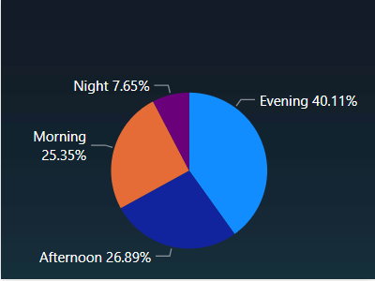

From the Chart it is clear evident that most of the riders are travelling by evening time that is from 4:00 PM to 9:00 PM

**Recommendations**

* Introducing new subscriptions plans for casual members based on more number of rides per week or day, which will be more appealing during Weekends. Hoarding, Bill board or Kiosk can be placed at start bike station for informing about the subscription scheme.
* The casual members might be more interested in membership option that allows for the per-use balance card (punch Card). Alternatively the existing payment structure may be altered in order to make a single use more costly to the casual riders as well as lowering the long term membership rate and or offer a discounted promotional rate.
* Membership rates are specifically for the weekends would assist in targeting the casual riders more specifically. Introducing annual membership scheme for weekend ride alone which is cheaper that weekday per day rental charge.
* As the electric bike usage are very less, charging stations can be implemented in those top 10 Starting stations and on spot service options might push the usage. As electric bikes are eco friendly you can receive a green ride award from the US Government for the Chicago city which will be the competitive advantage compared to a core competitor.
* To find new annual customers you can target the school students between age 12 to 16 who are all using the school bus paying more fee, they can opt a electric bike for the transportation or you can target food delivery staffs in the hotel & restaurants whose salary is very less or those who looking for the part time jobs in food delivery as they need the two wheeler which is mandatory.

**Things to consider (Add on Points)**

The scope of the analysis is limited to some extent as additional data might have been able to contribute to this report offering even more granular analysis.

**Data could have been added**

Age & gender, Pricing Structure or a plan, which helps to analyze the spending behavior also their profession, income data, which helps to analyze the economic stands for each type of Member.

**Data Interpretation and Cleaning**

From this dataset I found that there are more empty cells in Start Station Name, End Station name, Start Station ID and End Station ID, these refers to the location or area where the riders starting and ending, but the longitude and latitude are given with 0% empty cells so we can use these parameters and can be used in the map chart to find the accurate location. So I have the deleted the above mentioned empty cells columns.

Dax Functions Used

Average Time Duration- DATEDIFF('Cyclist riders'[started_at],'Cyclist riders'[ended_at],MINUTE)

Travel_type = IF('Cyclist riders'[Days]>0,"Long_Day travel","Same_Day Travel")

Annual_Members = CALCULATE(count('Cyclist riders'[ride_id]),'Cyclist riders'[member_casual]="Member")

Casual_Members = CALCULATE(count('Cyclist riders'[ride_id]),'Cyclist riders'[member_casual]="casual")

Annual% = ([Annual_Members]/count('Cyclist riders'[ride_id]))

Casual% = ([Casual_Members]/count('Cyclist riders'[ride_id]))

Days = datediff('Cyclist riders'[started_at],'Cyclist riders'[ended_at],DAY)